Metadata Analysis (YouTube / Documents)

Metadata analysis is use to extract information from a YouTube Video
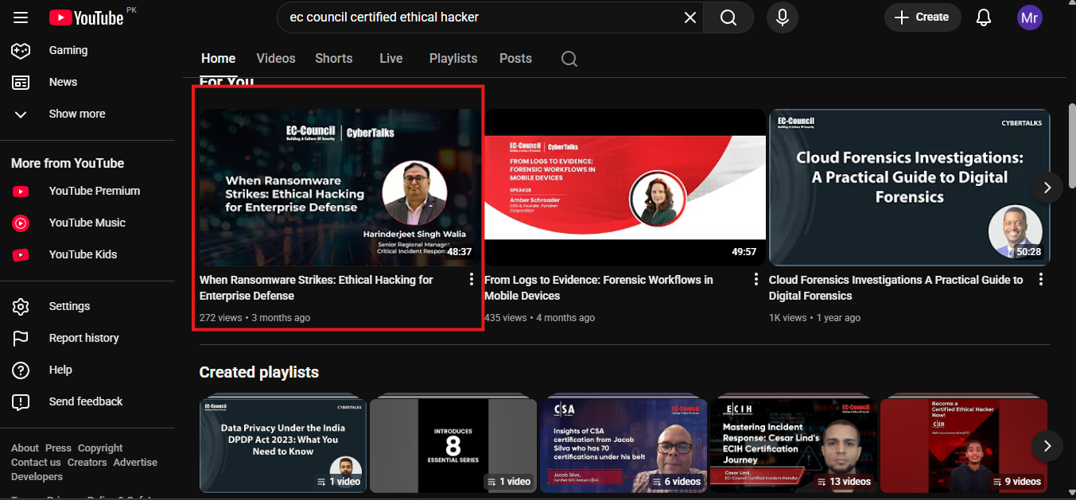
We have selected the video from eccouncil yt channel and now we copy the link and share to metadata for further information.
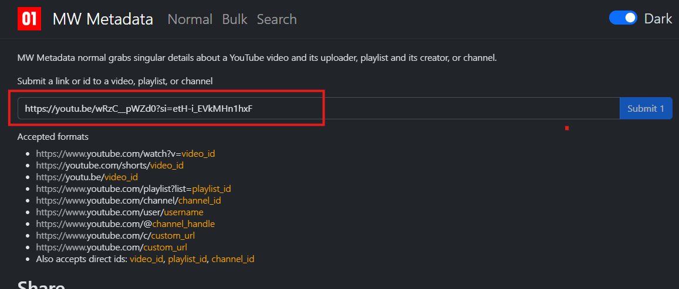 We have pasted the link in MW Meta data Now we will look for the information.
Major Findings:

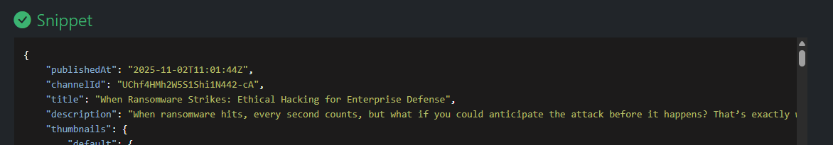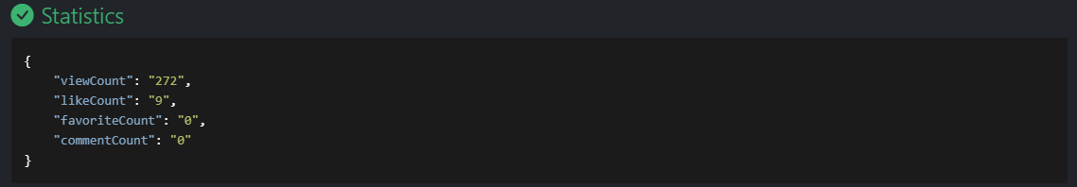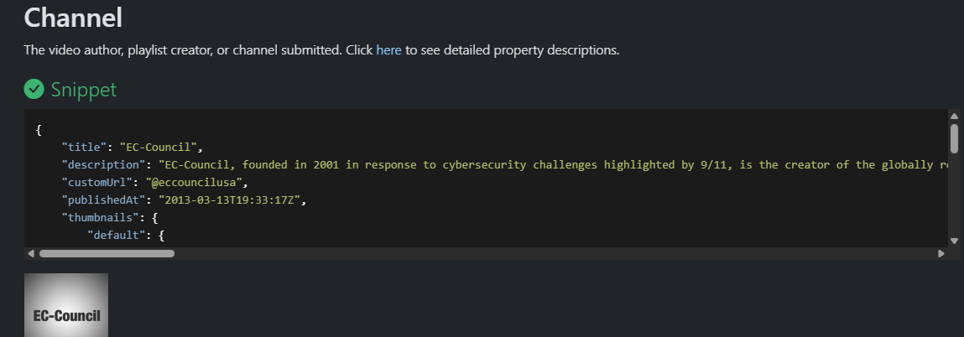 We have gathered an information like when the video is published what’s the channel id and views like and counts of video.

How metadata help attackers?
Sometimes metadata reveal sensitive information like user name or any social media acc so attacker can use that for phishing .

